CURRICULUM VITAE INFORMATION

PERSONAL DETAILS |  |  |  |  |  |  |  |  | 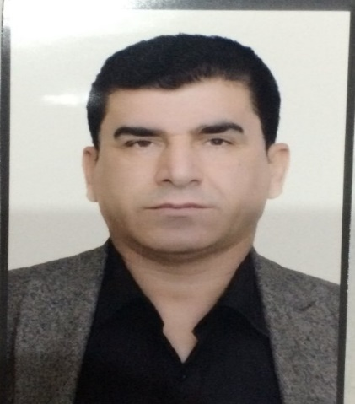
FULL NAME | HUSSEIN ASAAD FINDO ASAAD
ADRESS | UNIVERSITY OF DUHOK  COLLEGE OF BASIC EDUCATION /AMEDI
DATE & PLACE OF BIRTH | 4/9/1970 – AMEDY-NERWA-REKAN
SEX | MALE | MARITAL STATUS |  |  |  | MARRIED
MOBILE | 07504587847 |  |  |  | UNIVERSITY E-MAIL |  |  | hussein.findo@uod.ac
NATIONALITY | IRAQI-KURDISH |  |  |  | PERSONAL E-MAIL |  |  | findohussein@gmail.com
LANGUAGES | KURDISH-ARABIC- ENGISH
EDUCATION and QUALIFICATIONS
Name and address of  school, college or university |  |  | Dates attended |  |  |  | Subjects /courses taken and qualifications obtained
Sheladeze primary school |  |  |  | 1977-1982 |  |  | Primary certificate
Sheladeze secondary school |  |  |  | 1983-1995 |  |  | Intermediate certificate
Deralok preparatory (high) school |  |  |  | 1986-1988 |  |  | High school degree /literary branch
Technical Institute of Mosul /  Mechanic Department |  |  |  | 1989-1990 |  |  | Technical diploma degree
Duhok directorate of Education  (outside examinations ) |  |  |  | 1995 |  |  | High school degree/ scientific branch
Duhok University / College of Arts  ( Faculty of Humanities) /  English Department |  |  |  | (1996-1997) till  (1999-2000) |  |  | Bachelor of Arts / English Department
Duhok University / English Dept. |  |  |  | 2011-2014  -In 25/10/2020 |  |  | -MA.(Master of Arts ) degree in English Language and Linguistics.  -I 've been accepted as a candidate of Ph.D. degree in Dohuk University and now I am still a Ph.D. student
Working Experience |  |  |  | -2000- 2018 English Teacher at Sheladeze High School  -2003 English lecturer in a course of teaching English language for the teachers of Amedi district  -2015 English lecturer in a course of teaching English language for the teachers of primary schools in Amedi district  -In 29/11/2018 I have been moved from the personnel of Ministry of Education to the personnel of Ministry of Higher Education/College of Basic Education Amedi
Organizational Experience |  |  |  | -2004 Assistant director in Sheladeze High School.  -2005-2007 Director of Hetit Scondary School.  -In 10/12/2018 I became a coordinator in College of Basic education /Amedi /English Department.  -In 4/8/2019 I left the coordinator job and became a teaching staff again in College of Basic Education/Amedi.  -in 16/10/2019 I got my scientific title as assistant lecturer at Duhok University.  -Now I am assistant lecturer at the college of Basic Education /Amedi / English Department and Ph.D. student.
Other Skills |  |  |  | (1991-1993) A clerk in the administration affairs in one of the Iraqi Military sectors in Mosul and in Al- Ramady.  (2004- present) English Private lessons Teacher for the  12-Grade students and learning English language courses for the public students

Note : This information has been updated in 20/12/2021

