


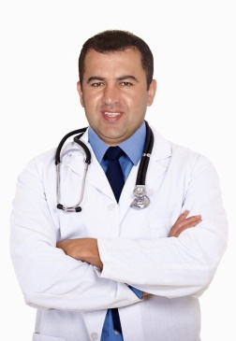
]
ghazidigwar@gmail.com
Date of birth 1 April 1980
Xorteen st.1000 Duhok city

009647504581202

Dr.Dezhwar
Yahya ghazi
General surgeon MBChB .FIBMS
General surgeon in open , laparoscopic and trauma surgery with experience of about 14 years in surgical practice with multiple different abdominal, thyroid ,breast ,hernia, abdominoplasty , different oncological and diabetes mellitus problems related operations. Working in both governmental
And private hospitals and in private clinic .
SKILLS
- Good communication skills
- Open and laparoscopic surgery

LANGUAGES
English

kurdish

EDUCATION
Arabic turkish
1995 -1998
Kawa secondary school ,duhok

student

duhok, iraq

University of duhok , Colleage of medicine
Duhok , iraq
ombia

1999-2005
Iraqi board general surgery training programm.
Student MBChB
ole, lycée ou collège
2011-2016
Iraqi board degree in general surgery FIBMS

Duhok ,sulaimanyia,erbil ,Baghdad iraq

WORK EXPERIENCE

- Working as junnior house officer in different departments in azadi teaching hospital like surgical ward, emergency medicine unit ,ICU unit and urosurgery ward.
- Hivi Pediatric care hospital for 3 month .
- Obstetric and gynecology hospital for 3 month .

Junior house officer

Azadi teaching hospital ,Hivi pediatric hospital ,Duhok emergency hospital

Duhok , iraq

SEP 2005– OCT. 2007

Oct. 2007 –Dec. 2008
- rural and village doctor in primary health care center in atrush municipality in shexan district.

Duhok, Iraq
Oct .2011 –june.2016
June .2016 –Dec .2019
Dec .2019 –july .2021
May 2021 . participating in liposuction training coarse in Egypt cairo.

- Senior house officer in Duhok emergency teacghing Hospital

- iraqi board candidate training in both Azadi Teaching hospital and Duhok emergency Teaching hospital .
- senior in general surgery in gulan general hospital in akre district .
- senior in general surgery in Duhok Emergency Teaching Hospital.

Duhok , iraq
res, Argentina

Dec. 2008 –Oct. 2011

