Personal Information |  |  |  |  |  |  |  | 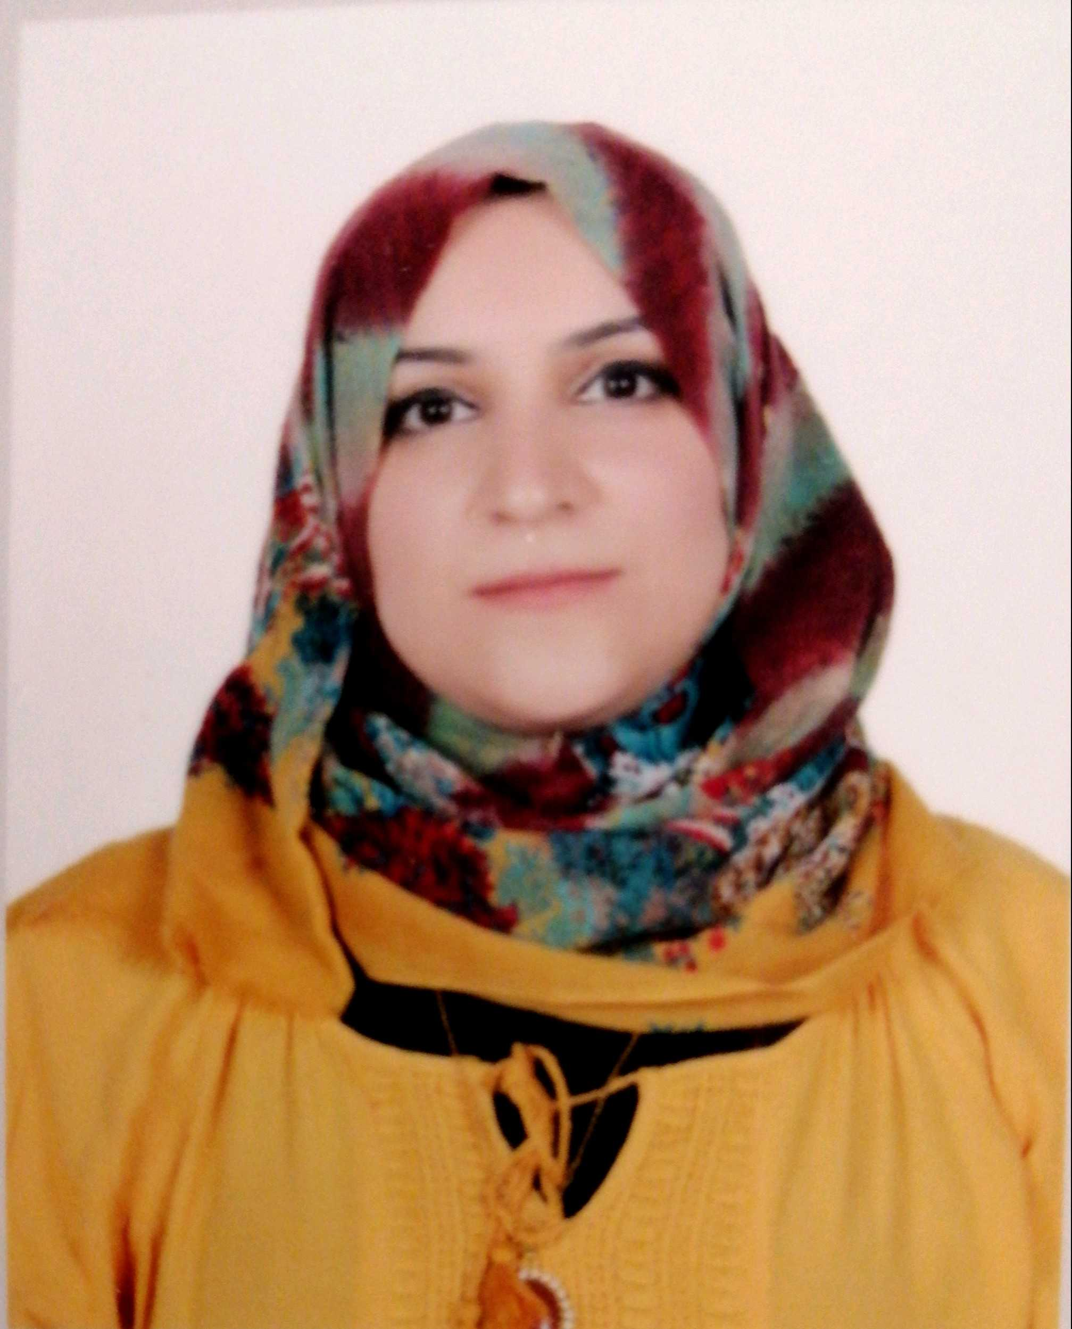
Name |  | Raghad Khazaal Abes
Nationality |  | Iraqi
Date of Birth |  | 24/8/1985
Place of Birth |  | Mosul |  |  |  |  |  | Marital Status | Single
Contact Information
E-mail |  | Raghadalnajar63@gmail.com |  |  |  |  |  | E-mail |  | Raghad.abed@uod.ac
Home Address  (Permanent Address) |  | Dohuk/ masake 1 |  |  |  |  |  | Mobile No. |  | 009647508940209
Education
Degree |  |  | Bachelor |  |  | Master |  |  |  |  | Scientific Title
University Name |  |  | University of Al Mosul |  |  | University of Al Mosul |  |  |  |  | Assistant teacher (lecturer)
Country |  |  | Iraq |  |  | Iraq
Date of obtaining degree (Day/Month/Year) |  |  | 2007 |  |  | 2014 |  |  |  |  | 2014/ Duhok University
Bachelor (Major /Specialization) |  |  |  |  |  | Law
Master (Major / Specialization) |  |  |  |  |  | Public Law
Title of Master Thesis |  |  |  |  |  | Public Finance and Financial Legislation
Title of PhD. Dissertation

Experience in University of Duhok- Iraq
From  D/M/Y | To  D/M/Y |  |  |  | Position /Title |  |  |  |  |  |  | Nature of work
Courses Taught
2021-2020 Department of Administration / college of Administration and Economic / university of Dohuk ---- Commercial of law
2014-2021 Department of Law/ the College of Law and Policy / Nowruz University --- Public finance and financial legislation
2018-2020 Department of Law/ the College of Law and Policy / Nowruz University ---- Arabic language course
2015-2018 Department of Law/ the College of Law and Policy / Nowruz University ---- Human Rights
2014-2015 Department of Public Finance / Faculty of Management and Economics / university Nawroz --- tax legislation
Activities
Scientific Research Published |  |  |  |  |  |  | Journal /Institution |  |  |  |  |  | No. and Volume/Year
Revenues from the transport facility (comparative legal study) |  |  |  |  |  |  | Al-Rafidain Magazine / Mosul University |  |  |  |  |  | 2013
Conferences |  |  |  |  |  |  | University-City |  |  |  |  |  | Year
Workshop (scientific promotions) |  |  |  |  |  |  | Mosul University |  |  |  |  |  | 2020
Workshop (how to organize and prepare scientific research) |  |  |  |  |  |  | Mosul University |  |  |  |  |  | 2020
Workshop (how to write and publish academic research), |  |  |  |  |  |  | Al-Imam Al-Azam College |  |  |  |  |  | 2020
Workshop (legal and legal responsibility arising from the transmission of viruses and infectious diseases) Division of Continuing Education |  |  |  |  |  |  | Imam Al-Sadiq University |  |  |  |  |  | 2020
How to Get A Suitable and Fast Journal for your Manuscript Continuing Education Division |  |  |  |  |  |  | University of Kufa |  |  |  |  |  | 2020
Workshop (the meanings of scientific terms, science, culture and entertainment) |  |  |  |  |  |  | University of Mosul |  |  |  |  |  | 2020
Workshop (Safety of the Arabic Language in Official Addresses) |  |  |  |  |  |  | Dhi Qar University |  |  |  |  |  | 2020
Workshop (Town Planning and Safety in the Disaster and Crisis) |  |  |  |  |  |  | UNICEF |  |  |  |  |  | 2020
Workshop (healthy nutrition) |  |  |  |  |  |  | Samarra University |  |  |  |  |  | 2020
Workshop (Realizing Financial and Administrative Corruption in Iraq) Center for Continuing Education |  |  |  |  |  |  | Basra University |  |  |  |  |  | 2020
Workshop (controlling fraud in electronic exams) |  |  |  |  |  |  | Al Furat Middle Technical University |  |  |  |  |  | 2020
Workshop (different method of applying electronic tests on a platform google classroom) |  |  |  |  |  |  | Central Technical University |  |  |  |  |  | 2020
Commitment to enhance safety against COVID-19 As defined |  |  |  |  |  |  | the World Health Organization / WHO |  |  |  |  |  | 2020
Workshop (Iraqi women, reality and challenges) |  |  |  |  |  |  | Imam Jafar Al-Sadiq University |  |  |  |  |  | 2020
Let's Break the Chain of COVID-19 Infection |  |  |  |  |  |  | Mohammed bin Rashid University of Medicine and Health Sciences / United Arab Emirates |  |  |  |  |  | 2020
ONLINE WASIT FIRST INTERNATIONAL CONFERENCE ON CORONAVIRUS PANDEMIC |  |  |  |  |  |  | Wasit University |  |  |  |  |  | 2020
Health Education Ambassador for COVID-19 |  |  |  |  |  |  | The Ministry of Higher Education in Iraq |  |  |  |  |  | 2020
Workshop (successful preparation of records) |  |  |  |  |  |  | Ajman Relief and Development Organization |  |  |  |  |  | 2020
Legal workshop entitled (the crime of spreading a virus covid 19 |  |  |  |  |  |  | Tikrit University |  |  |  |  |  | 2020
E-learning breaking time, Space, and Pandemic |  |  |  |  |  |  | The ITRDC in University of Kufa |  |  |  |  |  | 2020
((Administrative Decentralization in the Kurdistan Region of Iraq)) Reasons and Implications |  |  |  |  |  |  | Department of Political Science at the College of Law and Policy / Nowruz University |  |  |  |  |  | 2020
Information technology and the human right to information privacy |  |  |  |  |  |  | Department of Law at the Faculty of Law and Policy at Nowruz University |  |  |  |  |  | 2020
((Drug abuse between medical treatment and legal punishment)) |  |  |  |  |  |  | Department of Law, Faculty of Law and Politics, University of Nowruz |  |  |  |  |  | 2019
The future of Kurdistan in the Middle East under the new regional and global variables |  |  |  |  |  |  | Department of Political Science at the Faculty of Law and Policy at Nowruz University |  |  |  |  |  | 2018
Seminar / Health Legislation in Iraq and the Kurdistan Region Between Reality and Ambition , |  |  |  |  |  |  | Department of Law, College of Law and Policy, Nowruz University |  |  |  |  |  | 2018
Elections in Iraq and the Kurdistan Region and its domestic and international repercussions |  |  |  |  |  |  | Department of Law in cooperation with the Centre for Research and Development / Nowruz University |  |  |  |  |  | 2017
The referendum and its repercussions on the Kurdistan Region |  |  |  |  |  |  | Department of Law, Faculty of Law and Politics, Nowruz University |  |  |  |  |  | 2017
Legal Protection of the Displaced - A Study of the Conditions of the Displaced in the Kurdistan Region / Iraq / |  |  |  |  |  |  | Department of Law at the Faculty of Law and Policy at Nowruz University |  |  |  |  |  | 2017
Centre for Scientific Research and Development Scientific Secretariat and Intellectual Property Rights |  |  |  |  |  |  | Nowruz University |  |  |  |  |  | 2017
The Third Scientific Conference of the College of Law and Politics Contemporary International Terrorism - Reasons, Implications, and Ways of Confrontation - The Kurdistan Region Experience / Iraq as a Model |  |  |  |  |  |  | Nowruz University |  |  |  |  |  | 2017
Legal Organization of Nationality / Department of Law, Faculty of Law and Policy, |  |  |  |  |  |  | University of Nowruz |  |  |  |  |  | 2017
The Kurdish State between Reality and Ambition / Future Legal Study |  |  |  |  |  |  | Department of Law at the Faculty of Law and Policy at Nowruz University |  |  |  |  |  | 2017
Legal protection of ingredients rights in the Kurdistan Region of Iraq |  |  |  |  |  |  | Department of Law, College of Law and Politics, Nowruz University |  |  |  |  |  | 2016
The second scientific conference of the Faculty of Law and Politics / The role of legislation in combating corruption |  |  |  |  |  |  | Nowruz University |  |  |  |  |  | 2014
Subjects Teaching
Public Finance and Financial Legislation , Administrative of law
Computer Skills
Software / Program |  |  |  | Level
Microsoft office (word,Excel,Access,ppt) |  |  |  | Very well
Network |  |  |  | Very well
Language Skills
Language |  |  |  | Level
Kurdish and Arabic |  |  |  | Good – very well
English |  |  |  | Well
Other |  |  |  | -

