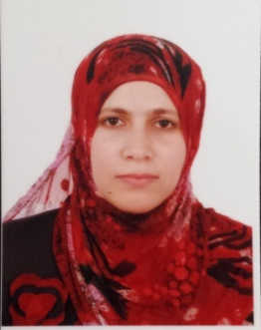
- Name : Khesar Hussein Khalil
- Date of birth : 9 April 1981
- Address : Duhok , Faida
- E. mail : khesar_2010@yahoo.com
- Mobile : 0750 4425372
- Languages: Arabic , English, Kurdish
- Scientific Title: Assistant Lecturer
- Date of Appointment to the University:
(2005, College of Medicine/ University of Duhok / Iraq).

Degrees Awarded
  - B. Sc., / College of Science / Department of Microbiology/ University of Mosul/ Republic of Iraq /Academic Year; 2003-2004.
  - M. Sc., Anatomy and Histology "Cytotoxic and Cytogenetic Effects of Crude and Some Active Compounds of Capparis spinosa on Tumor Cell Lines in vitro" Faculty of Medicine – School of Medicine / University of Duhok / Academic year : 2009-2010

Positions
  - Academic: Assistant lecturer, from 2010 – till now
  - (Now Ph.D. Student in Immunohistology)

